Contacts:

**Helen Norris** (VP & Chief Information Officer)

Email: hnorris@chapman.edu

**Shan Steinmark** (E-Village)

Email: Steinmar@chapman.edu

Creates a centralized platform that incentivizes students to get involved with their school, including Academic/Professional, Civic Engagement, Diversity/Cultural, Honor Society, Sport, Leisure, Recreational, and Religious/Spiritual.

Serves as a student service and a research mechanism, showing retention for all organizational events.

Data value involves student identification (school and personal), activity, and preferences. Sees which student is going where, how often, and at what time, along with their personal interests.

The data pertaining to retention for organizational events have never been grasped anywhere near it’s full potential. With this, data for all school-related events will be obtained significantly better than any other software developed.

By engaging students directly and setting an incentive to get them involved, campus culture will have a better chance of thriving.  Student engagement has a strong correlation to the overall success of student satisfaction and academic performance.

Student direct benefits:

* Platform that students will actually want to use. Will not be an event system completely run by an administration, harassing students with emails that they almost always delete upon receiving
* The administration will be viewed as a peer rather ‘big brother’ by equally advertising them as other organizations
* Incentivizes students with a reward system that can be overlooked by the school administration, filtering prizes as they so choose (raffles/automatic win). Also provides an automatic generator that notifies the users
* Will not require any effort to receive notifications on your phone besides clicking an RSVP button
* Cleanly manages all Organizations the user subscribes to
* Allows users to use “circles” which allows them to find friends and visualize what they are doing, compete to see who is obtaining the most points, and have private/public conversations with one another as well as invite them to anything they have RSVP’d for
* Will be able to communicate with organizations about their future events, leaderboards, and public and private chat groups as well
* Will be filtered originally by time but will also be filterable by the user so finding an event will be significantly easier

Organization direct benefits:

* Organizations will be able to advertise themselves in a platform that will is easy and fair to manage
* Much easier process of being found and overlooked than any other service
* Within creating an event, Organizations will be able to see other conflictions at their designated time
* Organizations will be able to compete with one another by purchasing more points at an inexpensive cost (offered at 5¢ per point dispersed by person)
* Organizations will be directly supported within the point system by the administration (each organization will be able to award each attendee a maximum of 10 points per week at no expense)
* Organizations will be able to be subscribed to and be able to organize all of its followers to be kept up to date in an organized fashion
* Organizations will be able to manage attendance electronically by overlooking their leaderboard

Administration direct benefits:

* The administration will be able to receive data of all activity going among its respective database
* The administration will be able to overlook the reward system and implement anything as they so choose
* The administration will be able to overlook the news feeds and report/delete inappropriate content
* The administration will have the capacity to manage their own events as well by declaring themselves as an organization
* The administration will have the capacity of scaling the point system as they deem fit
* The administration will have the same capabilities as an organization by declaring themselves as such
* The administration will be given a total of 5 private accounts that overlooks everything

Data Obtained & Significance

* Physical attendance
* Shows the true retention with all events, allowing direct evidence of positive or negative turnout
* Will be able to use this to see what advertisement mechanisms are successful and the popularity of programs allowing enhanced budgeting competence
* All event postings with interactions
* Posting consistency running with the organizational types and identifying outliers (Greek will be different than Academic etc.)
* Understanding the types of events that are being posted and understanding if there is an appropriate amount of everything going on
* RSVPs
* Correlation between physical attendance and RSVP
* Interactions within Subscriptions and Event sharing within profile system to see if personal profiling communication has served as a benefit
* Public communication (note: private will remain private will not expose)
  + Organizational
* Mechanism to see positive or negative interaction within the communication system and understanding if organizational helpfulness is being acclimated.
  + Personal
* Getting an idea of how people are interacting with one another on a public communication level.
* Necessary to allow communicational reign among one another for user satisfaction
* Point Interaction
  + Accumulation
* Understanding how much involvement there is and the success of the point system
  + Offering
* Organizational offering and seeing if that form of advertisement incentivizes more people to attend their events
  + Leader boarding
* Way for organizations to see for themselves the success within their strategies immediately and rewarding their leaders if they so choose
* Administration will be able directly overlook the interactions in this case

Known Competition

Handshake

Ordinem can be a direct form of advertisement for Handshake through campus administration.  The problem that Handshake has within many campuses is not being able to reach out to a majority of students.  By having a direct application service that can be filtered accordingly with a focus like (but not restrictive to) career building, the incentive will draw those to that source.

OrgSync

It’s really just a platform that is managed by the administration only.  Nobody wants to get hounded by the school constantly receiving emails to try to get me to go to some scheduling seminar.  Truly becomes more annoying than anything.  By unifying the system for the administration and organizations to manage events and work on the same platform, students will view it less of a "parent overlooking their kids” and more of a peer among peers sharing and promoting student engagement.

In addition, the idea of getting your card swiped when showing up to some class planning event just begrudges the student knowing that Big Brother is taking my data without getting some sort of reward out of it.

Furthermore

Starbucks app is a success:

“The app is increasing transactions by 15 percent to 20 percent in the U.S. –- a percentage that will only increase, according to Jack Russo, an analyst at Edward Jones & Co. Those extra purchases are one of the reasons behind Starbucks’ 17 percent revenue growth last fiscal year -- the biggest gain since 2007, when the company was half its current size.” –Kharif & Patton of Bloomberg Technology

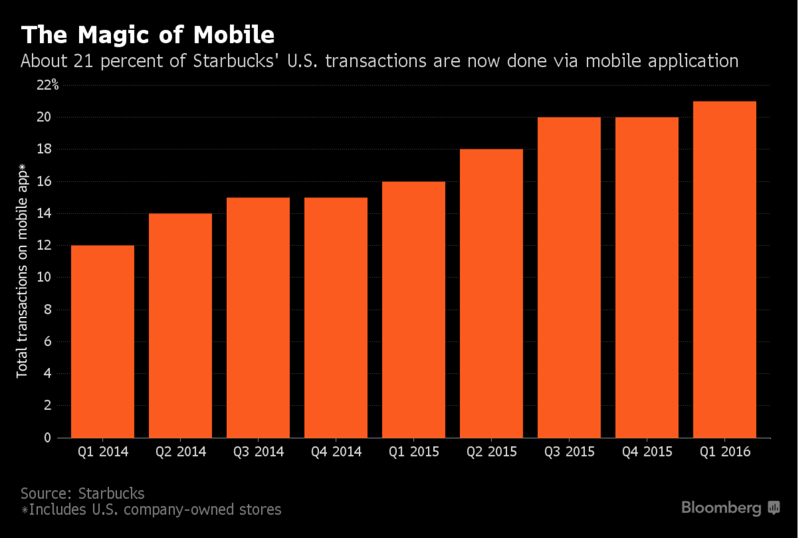

Personally viewed myself more as an Einstein Bros Coffee kind of guy but when the rewards app came out that allowed me to accumulate points that would get me a free coffee. I got gold status within 2 months of downloading it.  I found something that I ended up liking at Starbucks (strawberry acai refreshers) and haven’t been able to turn away since.  Why not develop a reward system for student engagement and let that new organization be the students' strawberry acai refresher.

(Write up the increase in profits, or customers when they implemented the rewards program)

Competition Conclusion: Can be a better form of advertisement for the platforms that schools already use or have the capacity to substitute it as a whole.

Everything, business and personal, have been pushing themselves towards a technological advance. Yet, schools have not had the proper implementations for them reach their full potential and get a strong hold of student services and the data within event retention. Ordinem will change that.

**Cost for service and data altogether: $10,000 + $65/student users in DB (by school)**

Note: Restrictive towards a fixed audience, so costs will never exceed a certain amount.

In this package: $10,000 = implementation fee. Gets the ball rolling with the school.

$65/user: Organizations are free as well as the administrative accounts. The data within the designated school provided is based on the number of students/faculty users there are. For that reason $65/user will be valued based on the service it provides and all the data interaction within it. This is restrictive based on the interaction for the respective school. No raw data will sold to other schools.

Data Interaction among all schools: TBD (presumably free or just make the $10k yearly. Maybe make it more)

Within the first year of launch:

**Deal with Chapman**

For every 5 schools they can refer us to that results in a deal, will give 1-year worth of data (minimum 5k enrollment). If they can accumulate 50 within 2 years, will give free data for life. They can allow us to use their database until we have enough profit to be able to get our own. Will automatically give them 1 year for free as a thank you if E-Village hooks it up.

**Deal with other Schools**

For every 10 schools they can refer us to that results in a deal, will give 1-year worth of data (minimum 5k enrollment).

Chapman University

2016 Undergrad Enrollment: 6,363

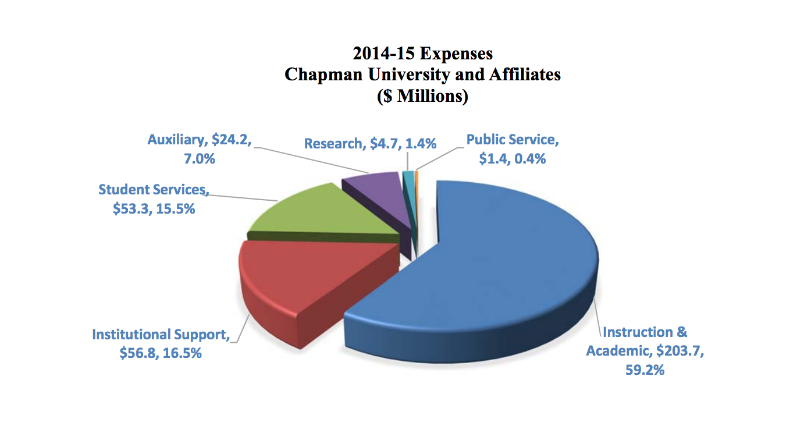

(Taken from Chapman University Financial Statement)

Overall student service costs: $53.3 million

Overall research costs: $4.7 million

Total: $58 million

Costs (with respect to 2016 undergraduate enrollment):

Cost for 20% student usage: $92,719.00 (0.160% of total)

Cost for 30% student usage: $134,078.50 (0.231% of total)

Cost for 40% student usage: $175,438.00 (0.302% of total)

Cost for 50% student usage: $216,797.50 (0.374% of total)

Cost for 60% student usage: $248,157.50 (0.445% of total)

Cost for 70% student usage: $309,516.50 (0.516% of total)

Cost for 80% student usage: $340,876.00 (0.588% of total)

Cost for 90% student usage: $382,235.50 (0.659% of total)

Cost for 100% student usage: $422,595.00 (0.73% of total)

Ohio State University

2016 Undergraduate Enrollment: 52,349

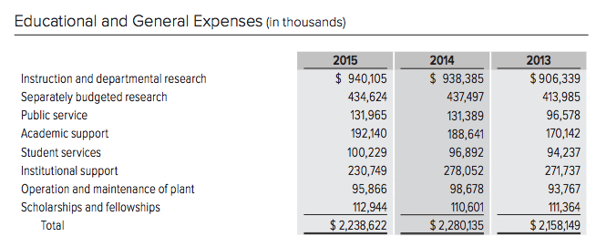

(Taken from OSU Financial statement)

Overall student service costs: $100.229 million

Overall budget research costs: $434.624 million

Total: $534.853 million

Costs (with respect to 2016 undergraduate enrollment):

Cost for 20% student usage: $690,537.00 (0.129% of total)

Cost for 30% student usage: $1,030,805.50 (0.193% of total)

Cost for 40% student usage: $1,371,074.00 (0.256% of total)

Cost for 50% student usage: $1,711,342.50 (0.320% of total)

Cost for 70% student usage: $2,391,879.50 (0.384% of total)

Cost for 80% student usage: $2,732,148.00 (0.447% of total)

Cost for 90% student usage: $3,072,416.50 (0.511% of total)

Cost for 100% student usage: $3,412,685.00 (0.638% of total)

University of California School Administration

2016 Undergraduate Enrollment: 197,422

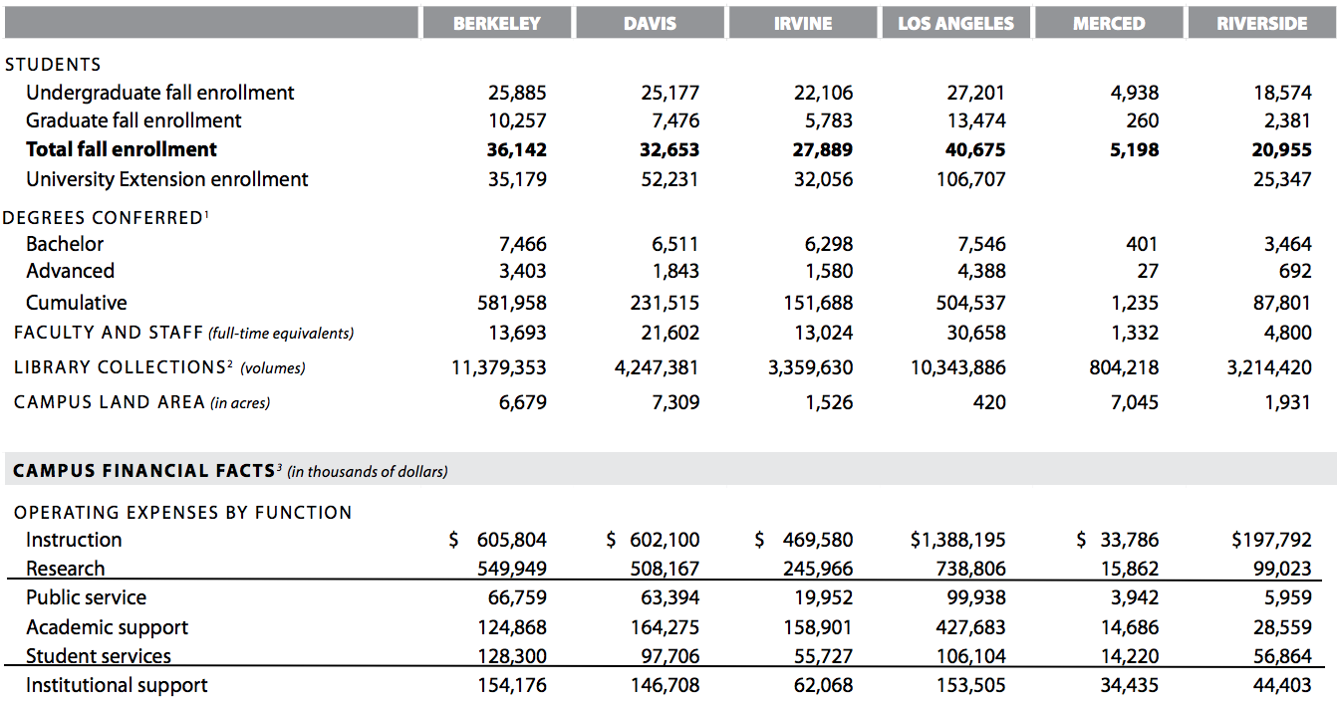

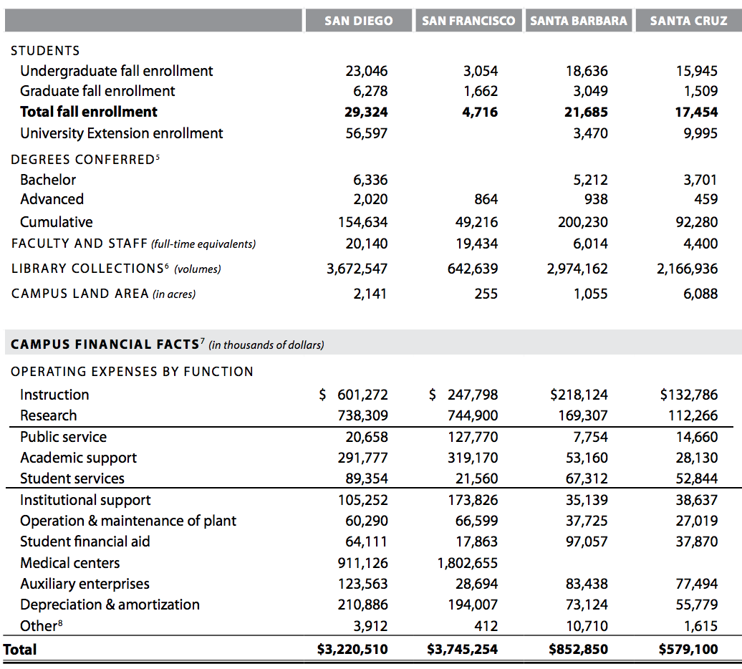

(Taken from University of California Financial statement)

Overall student service costs: $689.991 million

Overall budget research costs: over $4 billion

Costs (with respect to 2016 undergraduate enrollment):

Cost for 20% student usage: $2,576,486.00 (0.482% of student services alone)

Cost for 30% student usage: $3,859,729.00 (0.722% of student services alone)

Cost for 40% student usage: $5,142,972.00 (0.962% of student services alone)

Cost for 50% student usage: $6,426,215.00 (1.201% of student services alone)

Cost for 60% student usage: $7,709,458.00 (1.441% of student services alone)

Cost for 70% student usage: $8,992,701.00 (1.681% of student services alone)

Cost for 80% student usage: $10,275,944.00 (1.921% of student services alone)

Cost for 90% student usage: $11,559,187.00 (2.161% of student services alone)

Cost for 100% student usage: $12,842,430.00 (2.401% of student services alone)